GCR UAP for Fruitstand China

Instructions
Please completed Fruitstand Mandatory Confidentiality Training before reading this document.
This UAP updated as of 1/15/2026, is based on FS-GCR-UAP-2025H1 version. Key updates include:
- GCR CSPPA and AWS@FS vendor qualification progress in China region.
- 2025 work summary: Customer engagement, opportunities, purchase orders, revenue.
- 2026 action plans: Goals, plans, challenges, support needs.

0.Executive summary
This summary presents the major update from 2025 Q4.

CSPPA negotiations remain ongoing with an uncertain timeline because FS doesn't want to commit to consumption spending. Meanwhile, FS global procurement has indicated that there is no urgent demand for AWS in China, and negotiating the China contract is a low priority. This is preventing AWS from directly obtaining AWS@FS qualification in the China region through CSPPA execution.
Revenue result: In 2025, FS GC generated $500K revenue with 276% YoY growth, derived from 12 Purchase Orders across 4 LoB (FS Channel Sales, R&D, Care and iCloud) in China.
Revised the account strategy: Because we can’t to secure FS global procurement support for signing the CSPPA, we are trying to get help from FS China key stakeholders to advocate to the FS global procurement team to accelerate progress. Meanwhile, we believe AI is the customer's major workload with high growth potential over the next 3-5 years, rather than iCloud. We continue to engage in the customer's GenAI projects to earn their trust in AWS's full-stack GenAI capabilities.
LoB coverage: A significant breakthrough came when the AWS GCR FS China team participated in FS China's annual critical NPI (New Product Introduction) event for the first time via the AI training platform (AI Coach) for FS GC's channel sales LoB in October 2025. The AI Coach platform gained FS CEO Tim Cook's interest during his October 2025 China visit. Tim also initiated plans to expand the solution globally. This achievement not only elevated the FS GC Channel Sales team's internal reputation but also deepened AWS GCR's trusted partnership with the client, who expressed their appreciation through a formal thank-you letter.
Customer and competitor study: We have identified the major influence map and the major strategy and issues of AliCLoud. Meanwhile, figure out the customer’s procurement process and project landing journey.
Key Bloker & Risk
AWS GCR has not obtained the "AWS@FS" supplier qualification. Due to this compliance challenge, the current H20 workloads face the risk of migration to Ali Cloud anytime in Q1 2026. Additionally, if FS China's Apple Intelligence confirm partnership with Ali Cloud, it will be another obstacle to AWS-FS collaboration in China.

1. Customer Overview

1.1 Customer Profile Summary
Fruitstand (FS) is the world's largest consumer electronics and ecosystem services company, with a $4 trillion market capitalization ranking 2nd globally. Through its integrated "Devices + Software + Services" model, FS has built a robust ecosystem powering approximately 2.35B of active devices. The company's competitive advantage comes from 1) innovative hardware products that serve as customer entry points, 2) a tightly integrated ecosystem leveraging X OS, proprietary silicon (A/M series) and subscription-based services, 3) a highly efficient global supply chain.
FS operates on a fiscal year running from the last Saturday of September through the following year's last Saturday of September. In FY2025, FS achieved $416B in revenue (+6% YoY) with $195B gross profit (46.9% gross margin). Sales were primarily through indirect channels (60%) vs. direct sales (40%). The iPhone contributed 50.4% ($209.6 B) of total revenue, while Services accounted for 42% ($82 B) of gross profit. FS's sales regions are divided into 5 areas: Americas 43%, Europe 27%, Greater China 15%, Japan 7%, Rest of Asia Pacific 8%. Notably, Greater China region was the only one experiencing consecutive revenue decline, dropping from $73B(FY23) to $67B (FY24, -8% YoY) and further to $64B (FY25, -4% YoY). Relevant data can be found on the table below or refer to Appendix 6.3. Financial Overview for further details
Category | Products/Services | FY25 Rev.$ B | FY 25 Gross $B | Gross Margin
Devices | Smartphone: iPhone | $209.6B (50.4%) | $77B (39%) | 37%*
 | Personal Computer: MacBook Air/ Pro |iMac |  Mac mini/Studio/Pro | Display | $33.7B (8.1%) | $10B (5%)
 | Tablet: iPad Mini/Air/Pro | Pencil | Keyboard | $28B (6.7%) | $12B (6%)
 | Wearables, Home & Accessories: Apple Watch | AirPods | Apple TV | HomePod |Apple Vision Pro| Accessories | $35.7B (8.6%) | 13B (6%)
Software | iOS, macOS, iPadOS, watchOS, visionOS, tvOS… | NA | NA | NA
Services | - Advertising |  - AppleCare |  - Cloud Services (iCloud) |  - Digital Content (App Store, Apple Music, Apple TV+, Apple Arcade, Apple News+, Apple Fitness+)  - Payment Services (Apple Card, Apple Pay) | $109.2B (26%) | $82 B (42%) | 75%
Total |  | $ 416 B | $195 B | 46.9%
*Gross margins split by hardware, software, and services. Hardware and software margins are not separately detailed.

1.2 Customer Operation & Customer Stakeholders
[Organizational Structure] Fruitstand operates under a Functional Structure with single Profit & Loss management, comprising 20+ specialized departments (Refer to appendix 6.9.1 FS Org-X for further details). Due to strict confidentiality requirements, each LoB operates independently. Correspondingly, AWS GAM team has divided the different LoB into 10 “Parks”. Dedicated GAM manage and engage with their assigned “Park”. (Refer to appendix 6.1 Account Team for further details)
[China Operations] As of December 2025, FS maintains a workforce of 16,000 in China, #13 Entities distributed across Shanghai, Beijing, Shenzhen, Suzhou, Chengdu, and Chongqing. Fruitstand Greater China establishes most business lines corresponding to overseas business units, with each FS GC LoB vertically reporting to respective BU leaders at Cupertino HQ. Most business-related decisions are made by overseas BUs, while local teams focus on implementation and support. Isabel Ge Mahe (Chinese name: 葛越), the vice president and managing director of Greater China, reports to CEO Tim Cook and COO Jeff Williams, leading and coordinating local teams. (Refer to appendix 6.9.2 FS GC Org-X for further details). Meanwhile, we have identify the influence map as:
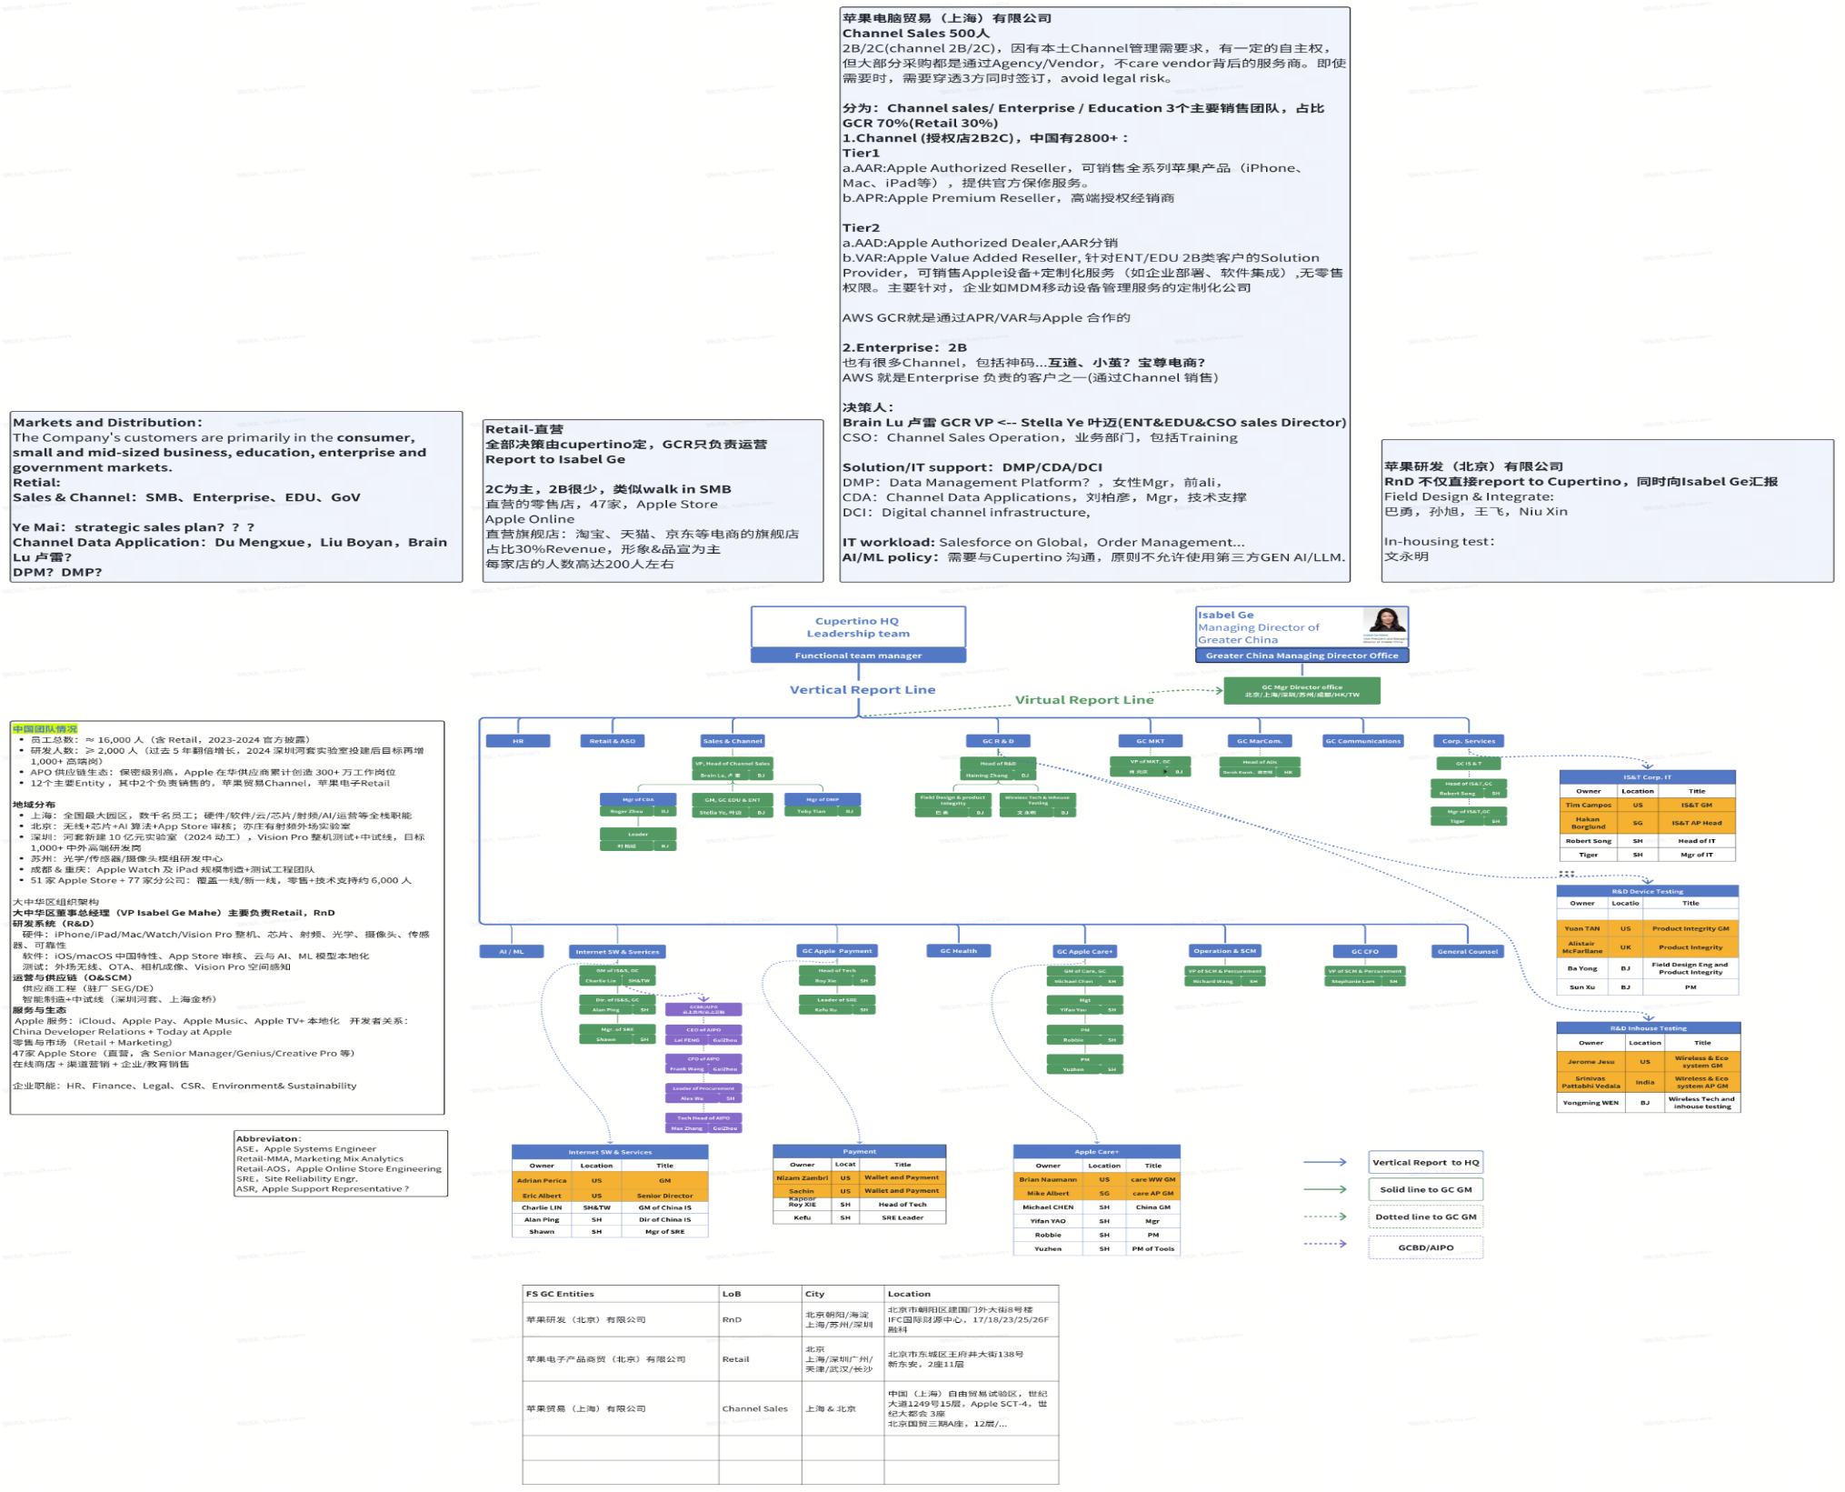
[iCloud China Operations] iCloud is Fruitstand China's largest workload and the only business unit using the Service Ownership and Responsibility (SOR) model in China mainland. Fruitstand operated iCloud independently from 2013 to 2019. To meet compliance requirements, Fruitstand transitioned to the SOR model in 2019, operating iCloud in China through GCBD (Guizhou Cloud and Big Data Group, 云上贵州) and its subsidiary AIPO (云上艾珀), with GCBD/AIPO as the state-owned company holding partial decision-making authority and final approval for third-party service contracts.

[Engagement Status] Fruitstand China account can be approached as a high potential account comprising multiple independent “greenfield accounts”. Currently, #4 LoBs are using AWS China Regions: Channel Sales, R&D, Care and iCloud(AIPO). Additionally, we have established direct connections with #2 LoBs, Internet Service, WPC departments. However, IS&T's engagement is blocked because AWS@FS qualification depends on CSPPA execution first. IS&T dept. requires this qualification to establish clear collaboration objectives before initiating any discussions. While we are exploring various ways to reach the remaining LoBs. The figure below lists the main stakeholders of the core business lines in China, stakeholders out of China are marked in orange. Business lines report vertically to global units, which make key decisions. Local teams handle implementation. The procurement department serves as the sole critical focal point for obtaining AWS@FS supplier status. (refer to Appendix 6.9.2.1 Customer Key Executive Coverage Status)

[Cloud Services Procurement Process] FS maintains strict supplier management standards through its Cupertino-based procurement organization, which oversees supply chain management, quality control, compliance, and sustainability. FS's cloud services procurement involves five central teams: Procurement, Finance, Cloud Infrastructure Business Operations (CIBO), Application Security Engineering (ASE), and Cloud Tech. Procurement serves as the only entry point, with neither Procurement nor Cloud Tech maintaining dedicated personnel in China. Even after CSPPA execution, onboarding typically requires 6-9 months to build and validate the AWS@FS platform through the Cloud Tech department. The detail procumbent process: (refer to Appendix 6.9.3 FS Central Team Org-X)

[AWS@FS Qualification Status and Compliance Risk] At present, NWCD and Sinnet have been added to FS's supplier directory. However, AWS GCR has not yet attained AWS@FS qualification within FS China's Cloud Tech portal, where only Ali@FS holds this status. Once AWS GCR obtains the AWS@FS qualification, LoB can directly request resources through the Cloud Tech Portal with unified payment processing. Conversely, without AWS@FS qualification in China, LoB must individually request POs from Procurement to pay cloud bills on a case-by-case basis. This approach not only increases commercial complexity but also creates compliance risks, with potential mandatory migration to Ali Cloud at any time.

1.3 Market/Industry Overview
As the world's second-largest company by market capitalization and a global multinational enterprise, FS faces a complex operating environment characterized by both significant pressures and strategic opportunities. According to PESTEC framework analysis as below:
- Political: 1) US-China trade war has led to continuously increasing supply chain and tariff costs. In FY25 Q3 alone, tariff costs increased by approximately $900 M. 2) Antitrust reviews from multiple countries threaten the ecosystem barriers related to the high-margin App Store, leading not only to reduced Apple Store commissions but also to massive fines.
- Economic: 1) Revenue is heavily concentrated in iPhone sales (50.4% of total). Any significant decline in smartphone sales would substantially impact overall revenue. 2) Economic pressures affect high-end product purchase demand and average extend replacement device cycles to 3+ years.
- Social: Growing consumer concerns over privacy and data tracking persist, with Apple fined €98.6M in Italy for privacy policy abuse in 2024-2025.
- Technological: Lagging Microsoft and Google in generative AI capabilities, creating competitive disadvantages in AI innovation.
- Environmental: Committed to carbon neutrality by 2030 (60% emissions reduction achieved)
- Competitive: Intense competition with Samsung, Google, Microsoft and Amazon across hardware, software, and services.
Given that 50.4% of FS’s revenue from iPhones. As the top global smartphone leader, it made $232B in 2024, which is 42% of the total $478B market. For detailed smartphone market analysis, pls refer to appendix 6.9.5 2024 Global and Chinese Smartphone Market Overview.

2. Customer Growth Strategy

2.1 Customer’s Business Priorities and Strategy
To address the above outlined challenges, risks, and uncertainties factors in section 1.3 Market/Industry Overview, Among FS's multiple strategic priorities, three are most critical:
- Accelerate AI R&D: 1) Invest $500B in US over 4 years including AI infrastructure, custom silicon etc.; 2) Integrate AI across all product lines; 3) Partner with ChatGPT and evaluate Gemini/Claude to enhance Apple Intelligence via hybrid on-device & Private Cloud Compute architecture plus selective 3rd APIs. 4) Accelerating the launch of Apple Intelligence in China.
- Services ecosystem revenue growth: FS aims for over 8% growth in FY26, maintaining 100-200M annual active device growth within its 2.35B device ecosystem. While FS is expanding into healthcare, home entertainment, and financial services, with focus on high-growth markets like India.
- Supply Chain Diversification: FS implements a "China+N" manufacturing strategy to balance geopolitical risk and supply capacity. By 2027, FS targets 25% iPhone production in India, 40% AirPods and 30% MacBook production in Vietnam, while maintaining China as the primary manufacturing hub and core market.

[FS Greater China's importance and strategy] As of December 2025, FS maintains a workforce of 16,000 in China, #13 Entities distributed across Shanghai, Beijing, Shenzhen, Suzhou, Chengdu, and Chongqing. China is of strategic importance to FS in two key aspects: 1) As the third-largest sales market ($64 billion in FY25, representing 15.5% of global revenue). 2) As the primary supply chain hub, where over 80% of suppliers operate, accounting for 44% of direct procurement spending.
For balance geopolitical risk and supply capacity, FS implements the "China+N" manufacturing strategy. By 2027, FS targets 25% iPhone production in India, 40% AirPods and 30% MacBook production in Vietnam, while maintaining China as the primary manufacturing hub and core market.
Furthermore, FS is aggressively accelerating the launch of Apple Intelligence in China to improve device sales and service subscriptions in the B2C market and penetrate the B2B market. According to recent reports, FS is negotiating regulatory approval with the Cyberspace Administration of China (CAC, 中国网信办) and partnering with local firms like Alibaba and Baidu to enter the Chinese market (Refer to appendix 6.9.4 for related reports).

[AWS Growth Opportunities aligned with FS China Strategy]
- Aligned with FS's AI strategy: Comprehensive AI Infrastructure and Solution Support, 1) Provide cost-effective GPU instance (A10, A100, H20, H200) in AWS GCR; 2) Deliver tailored AI consulting and implementation services aligned with each LoB's KPI requirements, leveraging AI Partner solutions, AI Lab, and ProServe resources.
- Aligned with FS's revenue growth strategy: 1) Advance joint GTM ecosystem collaboration between FS GC and AWS GCR targeting 2B enterprise customers; 2) Leverage AWS APN & AWS AI solutions to improve conversion rates at 2C retail stores. 3) Promote the launch of EC2 Mac Mini instances in AWS GCR to strengthen the ecosystem partnership, while enhancing AWS GCR service differentiation and attracting macOS developers.

2.2 AWS Customer Relationship Summary
The AWS global Fruitstand account is managed within AWSI Strategic Account BU. Led by Tunc Kirli, the account team comprises 2 managers, 9 BDs, and 7 SAs. Fruitstand is organized into 10 “Parks” covering different lines of business, with BDs assigned to specific Parks. Among the parks, Rainier led by Ovidio Calvo is responsible for China topics, incl. China EA, PPA, and iCloud China landing workload. In China, we rebuilt a new account team under Peter Cai in 2025 to drive business development in China and maintain regular communication with GAM and local customers. (refer to appendix 6.1 Account Team)
[History Relationship]
For AWS Global, Fruitstand signed a $6.9 Bn/5Y PPA (excluding GCR) as AWS's 3XL strategic global customer in December 2021. In 2024, negotiations are underway for a new CSPPA covering the China region; however, the signing timeline remains uncertain due to ongoing discussions around spending commitment terms.
For AWS GCR, NWCD and Sinnet have been added to FS's supplier directory. However, AWS GCR has not yet attained AWS@FS qualification within FS China's Cloud Tech portal, where only Ali@FS holds this status.
Without AWS@FS qualification, existing workloads deployed on AWS GCR face imminent migration risk to Ali Cloud, while severely limiting our engagement with FS China LoBs and restricting large-scale cloud service collaboration. Currently, we can only collaborate with limited FS GC LoBs on occasional, special project requirements through individual PO applications, creating operational complexity for FS LoBs. Obtaining AWS@FS qualification has become the top priority for AWS GCR.
To support the new CSPPA signing and accelerate AWS@FS qualification progress, 1) we strengthened communication with AWS Global GAM in 2025. Following a formal meeting between GB GM Danffer Ni and the GAM team in February, we established a monthly sync mechanism. 2) while actively exploring multiple paths to reach customer decision-makers, driving more business opportunities and POs. We will leverage FS GC requirements and POs as evidence, providing feedback to FS Procurement via GAM to raise awareness and accelerate AWS@FS qualification acquisition in China, 3) we also leveraged marketing events such as re:Invent to create more engagement opportunities with FS Health, Channel Sales, and Payment teams.
[History Revenue]
The annual revenues (after ID Exception) for the AWS Fruitstand China account over the last 7 years are as follows: (refer to Appendix 6.9.6 Fruitstand China History Revenue)

By Q4 2025, FS China's revenue reached $500K (30% in GCR post-ID Exception) with 276% YoY growth, across 4 LoBs (Channel Sales, RnD, Care and iCloud) and 12 POs. refer to appendix 6.9.7 Existing workload instruction
LoB | workload | ARR K  After ITA | AWS Services | related APNs | Why AWS
Channel Sales | AI Coach LLM+RAG | 200 | H20/A100/T4 | NA | C2C,  1. Operator’s AWS usage habits.  2. Cost-effective provision of H2O critical resources.  3. Ali cannot complete the network configuration in the short term.
 | Digital Human | 150 | MP2P ZITZO | ZITZO/Hudao | C2C, Cost-effective APN solution
RnD | Global unified data transfer testing | 50 | EC2 | DTO | NA | G2C, Global consistency requirements.
Care | APJ Care-ServiceOne | 30 | EC2 | RDS | ServiceOne | C2G, AWS is the preferred choice.
AIPO | iCloud control Engineering | 70 | Route 53 | NA | C2C, Early-stage project initiated in 2018
FS GC Channel Sales accounts for $350K (70% of total revenue), representing both the primary source of revenue and the highest risk workload. Without AWS@FS qualification in the Cloud Tech Portal, these workloads face potential mandatory migration to Alibaba Cloud at any time.
[Key Progress]
  - As a significant breakthrough came with the AWS GCR FS China team's first participation in FS China's annual critical NPI (New Product Introduction) event via the AI training platform (AI Coach) for FS GC's channel sales LoB. The 50-minute event attracted 16,000 attendees, with AWS GCR SA, SSO, and CSM providing full support. The AI training system handled approximately 160,000 online Q&As with a 100% response rate. The platform integrates aws marketplace H20 and AWS partner digital human solutions from APN partners ZITZO (集之互动) and IMS(天下秀) etc. The 2025 NPI event's success and innovative approach earned recognition from FS CEO Tim Cook during his October 2025 China visit, who initiated plans to expand the solution globally. This achievement not only elevated the FS GC Channel Sales team's internal reputation but also deepened AWS GCR's trusted partnership with the client, who expressed their appreciation through a formal thank-you letter.
  - In 2025Q1, we supported the Care LoB Go-APJ project, expanding a local China initiative to overseas markets using on-premises deployment in China and AWS Cloud for international coverage. This revealed the importance of APN ServiceOne Global Holdings Limited in delivering non-iCloud workloads through Fruitstand partners.

2.3 AWS Competitive Landscape
[Overview] Based on current understanding, FS has a $300M total addressable spend (TAS) in China. Due to the specific SOR operation model of iCloud business and its business sizing, we will conduct landscape analysis in 2 parts: iCloud related ($200M TAS) and non-iCloud related workloads ($100M TAS). Currently, AWS GCR captures $500K ARR (30% in GCR post-ID Exception) with 276% YoY growth, representing less than 1% of FS China's $300M TAS.
We are pursuing strategic growth opportunities targeting $60M over 30 months following the new CSPPA signing. with a new AI partnership evolution from infrastructure to solutions to GTM ecosystem. This expansion leverages both 1) enterprise workload migration to align with FS's global consistency standards. 2) Align with FS’s AI-First strategic, driving innovative workloads that unlock new opportunities beyond traditional iCloud. Establish a new partnership evolution from infrastructure to solutions to GTM ecosystem. and 3) proposed 300 PiB iCloud deployment through GAM collaboration, contingent on CSPPA execution.

[Key Competitor] Ali Cloud remains the primary competitor with three key advantages: 1) Exclusive AWS@FS qualification in China region. 2) Multi-year collaboration foundation on critical applications like iCloud; 3) Active engagement with regulatory agency (MIIT工信部, CAC 网信办) to advance AI infrastructure and solution partnerships aligned with FS's AI-first strategy. Conversely, network connectivity issues persist for FS GC services due to the absence of dedicated CloudTech management in China, preventing business units like Sales from accessing H20 GPU services.

#1 iCloud related, estimated as $200M TAS.
To comply with Chinese regulations, FS maintains two iCloud-dedicated data centers in China - Gui'an (Guizhou) and Wulanchabu (Inner Mongolia). While FS retains facility ownership, GCBD/AIPO manages operations at both locations.
Fruitstand iCloud China operates in a hybrid cloud model. The self-built data centers primarily handle workloads related to the iCloud partition and part of the storage as the backup and buffer for the 3rd party storage service providers. Storage capacities are shared with multiple vendors: three Telco companies - China Telecom, China Mobile. China Unicom, and three top China local internet companies - Baidu, Ali and Tencent. (Detailed can refer to appendix 6.6 Workload Competitions Landscape Simulation Spreadsheets #1 iCloud related in GC)

#2 Non-iCloud related, estimated as $100M TAS.
Currently, the non-iCloud portion of the workload includes Fruitstand's main LoB workloads, such as SAP, Salesforce, payment, R&D, and sales, among others. The TAS for this is estimated to be around $100 million. Based on feedback from the Line of Business and project stakeholders, Fruitstand strictly adheres to the global consistency policy. All procurement processes and compliance management are routed to headquarters, with limited local delegation. (Refer to Appendix 6.6 Workload Competitions Landscape Simulation Spreadsheets #2 non-iCloud related)

[Competitive Trends and Market Outlook] FS China's TAS is projected to grow from $300M to approximately $500M over the next three years, driven by AI service deployment and new applications. However, China's highly competitive cloud market and regulatory requirements position Alibaba Cloud as the primary competitor across 3 critical areas:
1. AWS@FS Qualification: AWS GCR currently lacks AWS@FS qualification in FS China's Cloud Tech portal (exclusive to Ali@FS), limiting engagement with FS China LoBs and large-scale collaboration. We are pursuing CSPPA signing with GAM support, using existing PO volume to demonstrate qualification necessity to FS headquarters procurement.
2. iCloud collaboration: Alibaba Cloud has established a strategic collaboration with AIPO to provide comprehensive cloud computing resources for iCloud operations.
3. AI Strategic Partnership: FS is advancing Apple Intelligence deployment in China, negotiating CAC (中国网信办) approval and partnering with Alibaba and Baidu for market entry. If Alibaba becomes the LLM provider and/or AI compute provider for Apple Intelligence, this will significantly strengthen their competitive position.

3. AWS Solutions & OneTeam Strategy
In 2025, we will attempt to make a breakthrough by strengthening collaboration with the Global team and the customer's PPA procurement. Meanwhile, dive deep local LoB pain point to drive local opportunity development. With the support of the global team, we had in-depth discussions and analyses on the expansion of Fruitstand’s business in AWS China Regions. We discussed seven Parks and over twenty pipelines, clarifying both short-term and long-term goals. We identified that iCloud China landing and Payment China landing are the top priority workloads. We also determined that the procurement and Cloud Tech of the client are the key LoBs with which we need to establish and strengthen communication.

AWS Value Proposition
To support Fruitstand business growth, AWS Fruitstand global account team updates AWS strategy annually and was reviewed by AWS leadership team. Here is the business strategy for AWS from Fruitstand global account team：
- Reduce AWS adoption friction to be the easiest and most cost optimized cloud platform.
- Innovate with our customers through partnership with AWS service teams.
- Leverage account team scale (and the deep BU engagement it enables) to expand customer relationships at every level and win new workloads.
- Deliver results through intentionally crafted account team structure, culture and operational excellence iterated over the years.
AWS is committed to enabling Fruitstand's digital transformation in China by combining our global technology leadership with deep local innovation capabilities. Our strategic priorities include:
- For iCloud:
- Deliver consistent global technology standards and service architecture.
- Include the China region as part of the Global PPA with Fruitstand to increase the utilization rate of AWS in the China region.
- For non-iCloud LoB Business:
- Leverage the local customer team to accelerate the exploration and implementation of non-iCloud business.
- Establish the GenAI use case for Fruitstand China LoB, demonstrating the innovative value of the local team.
- Support the customer Lob business-related ecosystem, becoming a strategic partner for the digital transformation of Fruitstand China.

4. Actions & Execution

4.1 Account Team Action Plan (Full & Lite)
[Target] Based on the Customer Growth Strategy objectives, we set an ambitious target: capturing 20% of FS China TAS opportunities (60M-100M ARR) within 3-5 years, as FS China TAS is projected to grow from 300M to 500M during this period. And our 1H 2026 actions focus on four primary action plans:
1. Obtained Local stakeholder support to escalate the China requirements to Global
- Collect the 2025 POs (#12) and send them to Alan Ping, who is key PM and will forward it to FS Global procurement to prove the local requirements.
- Engage with FS Sales BU GM for co-selling to earn her trust and escalate the FS China@AWS issue.
- Enabling FS local use to try B200 for Agent fine-tuning by their AWS global account ID
2.Support CSPPA Execution
Securing CSPPA coverage China region marks a critical inflection point in AWS-FS China partnership, directly obtain AWS@FS supplier qualification and unlocking 60M in potential workload opportunities over 30 months, as projected in Q1 2025 assessments with GAM. While CSPPA negotiations remain ongoing, our immediate focus centers on the preparation phase, addressing:
- Maintain monthly GAM communication to track CSPPA progress and provide support.
- Complete technical and service consistency assessment and preparation.
- Build trust with LoB‘s decision-makers in advance by aligning with FS's AI-first and revenue growth strategies.
- Prevent AR issues that may impact CSPPA signing.

3. Pursue Multiple Pathways to AWS@FS Qualification in China
If CSPPA execution faces delays, we will leverage GAM's communication channels with FS Procurement to explore alternative qualification pathways. 1) we will drive and collect additional POs from FS Greater China and requirements for AWS GCR collaboration, providing feedback to FS Procurement particularly regarding AI service deployment technical cooperation. 2) If GTM ecosystem collaboration can be established in China with FS, we will pursue AWS@FS qualification through proactive internal team advocacy, such as AI on Mac hybrid cloud solutions in retail and advancing EC2 Mac mini instance launch in China.

4. Clarify FS GC Organizational Structure and Accelerate Local LoB Engagement
FS's confidentiality requirements create relative independence across departments and teams, effectively treating each LoB as distinct “greenfield” accounts. This naturally barriers BD engagement with different LoBs. Given FS's vertical reporting structure, we will continue leveraging GAM support and experience to accurately understand FS GC's China organizational structure. We will accelerate decision-maker engagement across FS GC LoBs using business topics and GenAI applications as hooks, understanding their business scope, workloads, TAS, AI strategy and police, evaluating potential revenue size.

5. New Partnership evolution of collaboration from Infrastructure to Solutions to GTM Ecosystem
We deepen collaboration through three progressive stages:
1) At the infrastructure level, while direct LLM service provision remains constrained by regulations in China, we provide differentiated, cost-effective GPU compute resources (H20, B200) supporting AI training and inference services alongside secure, stable, and reliable infrastructure assurance.
2) At the solution level, we engage early during project requirement phases, leveraging AWS industry expertise and APN solutions combined with open-source and AWS Partner AI offerings to deliver AI algorithm optimization, solution integration, consulting, and delivery services. Drawing on deep understanding accumulated through ten years of overseas collaboration; AWS delivers customized local service support with precise grasp of FS operational requirements and technical preferences.
3)At the Go-to-Marketing ecosystem level, we establish mutually beneficial collaboration models through resource exchange, including: a) advancing EC2 Mac mini instance availability to strengthen FS X OS developer ecosystem service capabilities with flexible delivery options; b) leveraging AWS GCR's 2B enterprise customer resources combined with FS's AI on Mac strategy to promote AI on Mac hybrid cloud solutions in scenarios such as retail intelligent store management, establishing sustainable ecosystem solutions that deepen collaboration and strengthen partnership stickiness.

[Three Differentiated Value Propositions]
1. Global Operational Consistency.
2. Enhanced Security and Stability.
3. Customized AI Consulting and Delivery Services.

4.2 Key Blockers (Full & Lite)
Based on current customer understanding and action plan, the following blockers remain:
1. AWS@FS Qualification Delay
Issue: CSPPA negotiations remain ongoing with uncertain timeline due to FS doesn't want to commit to consumption spending, preventing AWS from directly obtaining AWS@FS qualification through CSPPA execution. Even after CSPPA execution, the 6-9 month onboarding process for AWS@FS platform setup and Cloud Tech validation means revenue is unlikely before 2027.
Impact: Restricts direct LoB engagement and limits access to comprehensive workload and TAS information. Creates immediate compliance risks for existing 350K ARR Channel Sales workloads, which face potential mandatory migration to Alibaba Cloud at any time.
Action: Strengthen alignment with GAMs and LTs to accelerate CSPPA execution and explore alternative qualification pathways by collecting additional POs from FS Greater China and providing requirements to FS US Procurement department.

2. Competitive from Ali Cloud
Issue: Ali Cloud holds established advantages including exclusive Ali@FS qualification, earlier relationships with key LoBs (Channel Sales, IS&T etc.), and comprehensive AI service offerings. Conversely, AWS faces significant GenAI implementation gaps in China region, including insufficient GPU capacity, uncompetitive pricing, and limited GenAI service offerings.
Impact: First-mover advantage creates higher barriers for AWS market entry and workload capture. Alibaba's comprehensive AI stack—from infrastructure to platform services—combined with competitive pricing creates significant competitive pressure for FS China engagement.
Action: Develop competitive pricing strategy while highlighting AWS's distinct value propositions: global operational consistency, proven security practices, customized AI service implementation, and multi-dimensional GTM ecosystem collaboration.

3. GTM Ecosystem Collaboration Feasibility and Mechanisms
Issue: GTM ecosystem collaboration requires dedicated support from IBD, PSM/PDM, and SSO teams for early-stage feasibility assessment. Currently it lacks clear ownership and focused resources to rapidly evaluate viability. If feasible opportunities are identified, collaboration discussions must escalate from LoB-BD level to executive-level engagement between AWS GCR and FS leadership.
Impact: Without dedicated internal resources and executive sponsorship, strategic ecosystem partnerships cannot progress effectively, limiting ability to establish differentiated value propositions and strengthen partnership stickiness.
Action: Secure LT-level support to assign clear ownership and dedicated resources (IBD for retail solutions, PSM/PDM for solution development, SSO for EC2 Mac mini launch). Establish executive-level sponsorship for strategic collaboration discussions with FS leadership once feasibility is confirmed.

4.3 Leadership Asks (Full & Lite)
To ensure successful strategic execution for FS China, we request the following tactical support from AWS leadership:
1. CSPPA Negotiation and AWS@FS Qualification
Align with the global CSPPA negotiation team to ensure China region coverage remains a consistent term throughout CAPPS negotiations. Establish AWS GCR's AWS@FS qualification as a clear, prioritized objective with dedicated ownership and accountability. This qualification is critical to eliminating compliance risks for existing 350K ARR workloads and unlocking 60M in potential workload opportunities over 30 months,.

2. GTM Ecosystem Collaboration Resources
Assign clear ownership and dedicated resources for rapid feasibility assessment of GTM ecosystem initiatives:
- IBD supports AI-powered retail store management solution development and pilot implementation.
- PSM/PDM supports ecosystem collaboration solution assessment, integration, mechanisms, and promotion.
- SSO team engagement for EC2 Mac mini instance launch requirements collection and timeline assessment with global SSO team.
Once viable opportunities are confirmed, provide executive-level sponsorship for strategic collaboration discussions with FS leadership.

6.0 Appendices

6.1 Account Team (Full & Lite)
Note: If your table below is not pre-populating please review your Quip-Salesforce connection and then reload your page.
 | Park Name | Fruitstand LoB | GAM | China BD
1 | Rainier | iCloud, Procurement, Media & Entertainment | Ovidio Calvo | Ma yimin
2 | Olympic | SAP, AML | Sonia Sangster
3 | Yellowstone | AI/ML (Training) | Juan-Antonio Carballo | Huang tai
4 | Yosemite | IS&T, Cloud Tech, ASE Non-Media Platforms | CK Sridhar | Huang tai
5 | Cascades | Product, Manufacturing, Care | Andrew Beauchamp | Ma yimin
6 | Everglades | Ads Platform | Prasad Naik
7 | Acadia | Sales, AOS, MarCom | Susan Ho | Ma yimin
8 | Teton | Maps | Angela Gaffney
9 | Tortugas | WPC | Amit Kharb | Huang tai
10 | Arches | AI/ML (Inference) | Azeem Elaydath | Huang tai
11 |  | Health | Andrew Beauchamp | Huang tai
12 |  | R&D |  | Huang tai
13 |  | Supply Chain |  | Huang tai
14 |  | Finance
15 |  | HR
16 |  | AIPO (云上贵州） |  | Ma yimin
17 |  | AWS GAM Alignment |  | Peter

China Local Account Team
 | Name | Alias | Title | One Team Roles
1 | Peter Cai | petecai@ | Head of China Regions Pursue Team | BD Manager & Account Owner
2 | Tai Huang | taihuan@ | Senior BD | Account BD
3 | Sam Zhou | zhouyulin@ | SA Senior Manager | SA Manager
4 | Du Chenxi | chenxqdu@ | Solution Architect | Account SA
5 | Jasmine Chen | chnta@ | International Principal BD | International BD of G2C
6 | Janice Wang | wajuan@ | GCR SCE | iCloud SCE dealer
7 | Jing Zhang | zhanujin@ | GCR SCE | Cross service PPA dealer
8 | Xavier WANG | wangxy@ | China Regions SSO Lead | SSO focal for workload landing
9 | Wang Ang | angwang@ | Manager, GCR WWSO Storage | SSO - iCloud S3 storage
10 | Steven Wang | ximinwan@ | Manager, GCR WWSO Networking | SSO – iCloud DTO
11 | Li Xueqing | lixueqin@ | Sr GenAI GTMS | GenAI SSO
12 | Li Xu | lixulx@ | Sr Mgr, VAP & Telco | Telco partnership on iCloud
13 | Xu Tao | taoxum@ | Senior BDM | Digital Innovation

6.2 Opportunity Pipeline (Full & Lite)
Note: If your table below is not pre-populating please review your Quip-Salesforce connection and then reload your page.

6.2.1 Workload Summary from GAM
Workload Summary from GAM, here is the workloads as global consistency focus, consolidated by GAM and are engaging as a CSPPA deal from 2025 Q1.
 | LoBs | Workload Title | CY1 | CY2 | CY3 | 3yrs Summary
1 | Acadia | Retail-AOS | 3,000 | 4,000 | 5,000 | 12,000
2 |  | Retail-MMA | 250 | 400 | 550 | 1,200
3 |  | MarCom | 1,000 | 3,000 | 5,000 | 9,000
4 |  | Customer systems | 1,500 | 3,000 | 4,500 | 9,000
5 |  | Claris | 75 | 150 | 225 | 450
6 | Olympic | AML Athena | 150 | 250 | 450 | 850
7 |  | AML Ednor | 250 | 500 | 1,000 | 1,750
8 |  | AML Shurl | 100 | 150 | 350 | 600
9 | Yosemite | ASE Data Platform | 500 | 1,000 | 1,200 | 2,700
10 |  | ASE Data Services | 125 | 300 | 350 | 775
11 |  | IS&T - ETS | 75 | 150 | 175 | 400
12 |  | IS&T - GNS | 250 | 600 | 700 | 1,550
13 |  | IS&T - AIS | 75 | 150 | 185 | 410
14 |  | IS&T - Cloud Tech | 35 | 75 | 100 | 210
15 |  | ISDS | 200 | 400 | 600 | 1,200
16 | Tortugas | FS Pay China | 378 | 3,780 | 4,160 | 8,318
17 |  | FS Payment Systems | 294 | 2,940 | 3,230 | 6,464
18 |  | FS Trust and Safety | 168 | 1,680 | 1,850 | 3,698
19 |  | Total | 8,425 | 22,525 | 29,625 | 60,575

6.2.2 Opportunity Summary in AWS GCR
The following are the pipelines (total $40,845,670) created and managed in 2025
Opportunity Name | Created Date | Stage | Close Date | Total Opportunity
ZHY - Fruitstand China GC Sales Oct NPI Digital Human Course-Ware | 2025-10-20 | Committed | 2025-11-15 | $18,900
Fruitstand China-ZHY/BJS-FS-数字人Marketplace 2P 三张订单 | 2025-09-28 | Launched | 2025-09-28 | $8,811
Fruitstand China-ZHY-China Marketplace 2P Model-FS Digital Persona 912Event视频制作 | 2025-09-12 | Closed Lost | 2025-12-11 | $3,737
Fruitstand China-ZHY-China Marketplace 2P Model-FS Digital Persona AB Test交互定开 | 2025-09-12 | Closed Lost | 2025-12-11 | $2,089
Fruitstand China-ZHY-China Marketplace 2P Model-FS Digital Persona AB Test视频制作 | 2025-09-12 | Closed Lost | 2025-12-11 | $3,093
ZHY -Fruitstand GC Sale - NPI 2025 AI QA Assurence extra one more H20 | 2025-09-08 | Launched | 2025-10-05 | $5,000
BJS - Fruitstand China - Cross Service PPA for BJS | 2025-07-29 | Business Validation | 2025-12-01 | $19,575,900
ZHY -Fruitstand China -Cloud resource for AI tools | 2025-07-28 | Business Validation | 2025-11-30 | $80,000
ZHY -Fruitstand China -Digital Persona for AB test | 2025-07-25 | Committed | 2025-11-01 | $40,000
ZHY - Fruitstand China - Cross Service PPA for ZHY | 2025-07-24 | Business Validation | 2025-12-01 | $19,575,900
[APEX affect opp - need delete]BJS - Fruitstand China - Cross Service PPA for BJS c | 2025-07-24 | Closed Lost | 2025-10-01 | $0
BJS/ZHY Fruitstand China - FS Trust and Safety for WPC NO-EC2-PARC | 2025-07-03 | Closed Lost | 2026-01-01 | $255,000
ZHY -Fruitstand China -Ai Coach Pilot 2025 July to August 3 month PO add-on 2x NWCD MP H20+DX | 2025-06-30 | Launched | 2025-06-30 | $14,000
ZHY -Fruitstand China -Ai Coach Pilot 2025 July to Auguest 3 month PO on NWCD MP H20+DX | 2025-06-20 | Launched | 2025-06-20 | $7,000
GLB - Fruitstand China - Care LoB Unified System South Korea SMS NO-EC2-PARC | 2025-06-16 | Closed Lost | 2025-12-01 | $4,000
ZHY - Fruitstand China - Sales LoB Channel Sales Internal Enablement GenAI 数字人方案 NO EC2 PARC | 2025-06-12 | Committed | 2025-10-31 | $10,000
ZHY - Fruitstand China - Sales LoB 销售培训数字人课件生产和实时QA NO EC2 PARC | 2025-06-11 | Committed | 2025-10-31 | $5,000
ZHY - Fruitstand China - Sales LoB Digital Human Live Streaming POC NO-EC2-PARC | 2025-05-26 | Committed | 2025-10-31 | $20,000
BJS/ZHY-Fruitstand China-Health Platform China Landing NO-EC2-PARC | 2025-05-16 | Qualified | 2026-01-31 | $805,000
ZHY - Fruitstand China - Sales LoB Ai Coach 2.0 Roll out EC2 PARC | 2025-05-13 | Business Validation | 2025-11-30 | $83,334
GLB - Fruitstand China - Care LoB Unified System Go-APJ Project #MIG | 2025-04-25 | Launched | 2025-05-12 | $16,000
ZHY -Fruitstand China - Sales LoB AI Mate Project | 2025-04-17 | Launched | 2025-05-09 | $260
ZHY - Fruitstand China - Sales LoB AiCoach 2.0 Pilot P4d Q2 Quotation | 2025-04-03 | Launched | 2025-05-09 | $11,646
Fruitstand China-ZHY/BJS-Apply Payment Migration NO-EC2-PARC | 2025-03-31 | Closed Lost | 2025-09-30 | $0
BJS/ZHY-Fruitstand China-WPC migration #MIG NO-EC2-PARC | 2025-03-31 | Qualified | 2026-01-31 | $255,000
BJS/ZHY - Fruitstand China - ASO VOC GenAI Report NO-EC2-PARC | 2025-03-31 | Closed Lost | 2025-09-30 | $0
BJS/ZHY - Fruitstand China - Spot Check GenAI Assistanse Pilot NO-EC2-PARC | 2025-03-31 | Closed Lost | 2025-10-31 | $30,000
AO for Care LoB Unified System Go-APJ Project #MIG | 2025-03-30 | Closed Lost | 2025-05-30 | $16,000
 |  |  |  | $40,845,670

6.3 Financial Overview (Full & Lite)
Add past three years’ overall financial information for your customer. This is NOT specific to AWS.
Category | Products/Services | FY25 Rev.$ B | FY 25 Gross $B | Gross Margin
Devices | Smartphone: iPhone | $209.6B (50.4%) | $77B (39%) | 37%*
 | Personal Computer: MacBook Air/ Pro |iMac |  Mac mini/Studio/Pro | Display | $33.7B (8.1%) | $10B (5%)
 | Tablet: iPad Mini/Air/Pro | Pencil | Keyboard | $28B (6.7%) | $12B (6%)
 | Wearables, Home & Accessories: Apple Watch | AirPods | Apple TV | HomePod |Apple Vision Pro| Accessories | $35.7B (8.6%) | 13B (6%)
Software | iOS, macOS, iPadOS, watchOS, tvOS, visionOS… | NA | NA | NA
Services | - Advertising |  - AppleCare |  - Cloud Services (iCloud) |  - Digital Content (App Store, Apple Music, Apple TV+, Apple Arcade, Apple News+, Apple Fitness+)  - Payment Services (Apple Card, Apple Pay) | $109.2B (26%) | $82 B (42%) | 75%
Total |  | $ 416 B | $195 B | 46.9%
*Gross margins split by hardware, software, and services. Hardware and software margins are not separately detailed.
[Revenue by Product & Service]
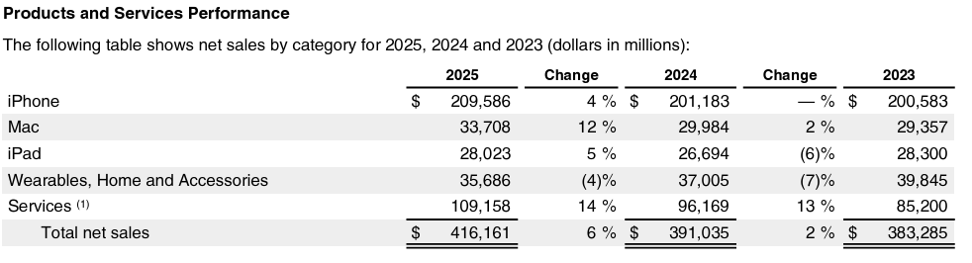
[Revenue by Region]
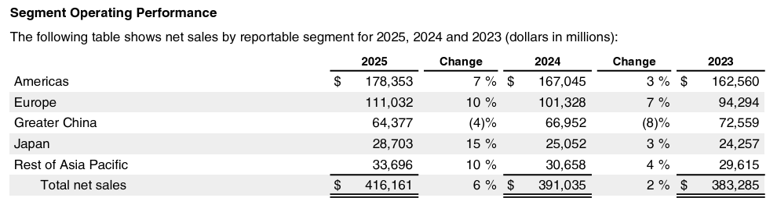
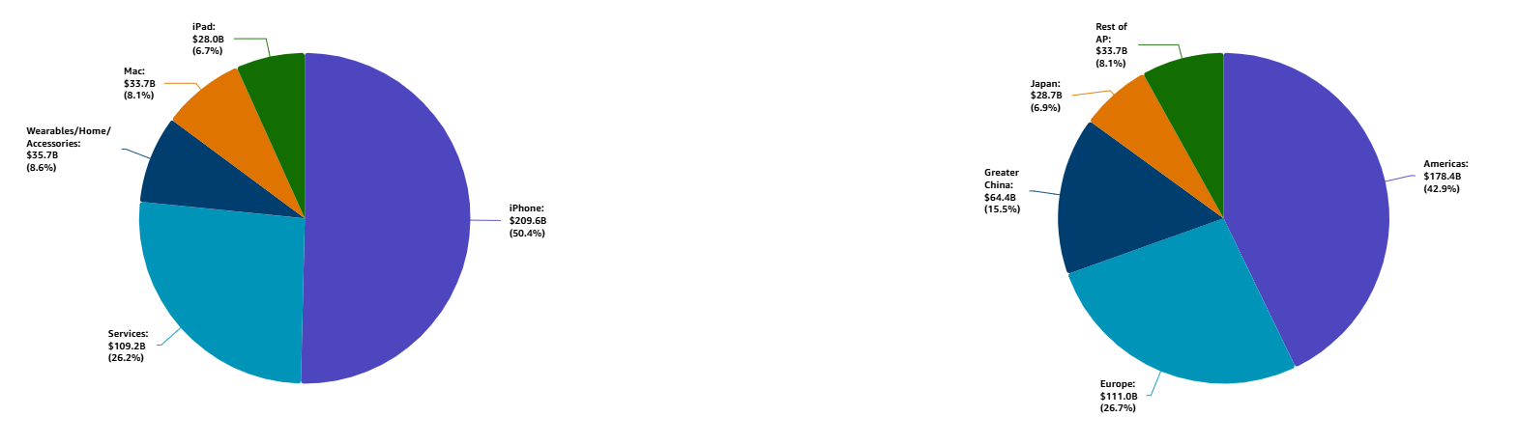
[Gross Margin]
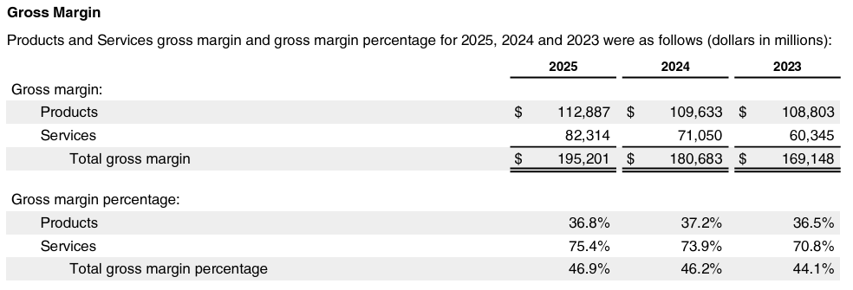

6.4 Partners Table (Full & Lite)
To associate a Partner from Salesforce: @Salesforce Data Mention > Insert > Select 'Account' > Search for the Partner you want to mention
To learn more about available co-sell programs and incentives, visit the Co-Sell Initiatives Hub

 | Partner Name | Primary Role (ISV, SI or MSP) | Relationship with Customer | Partner Sentiment (e.g. your Sales Relationship with Partner) | Key Workloads | Customer’s Annual Spend with Partner ($, estimate) | Involved Projects
1 | Nexttao | SI | Sales LoB | AWS China Regions Infra Services for 3rd party Application Developer | Sales management | 200,000 | Channel management
2 | Cognizant | GSI | IS&T | Approved local IT outsource vendors | IT labor and service | 4,500,000 | Identifying
3 | Infosys | GSI | IS&T | Approved local IT outsource vendors | IT labor and service | 2,000,000 | Identifying
4 | 集之互动

6.5 Top AI Use-Cases Table (Full & Lite)
 | GenAI Use-Case | Department or Line of Business | Challenges or Risks | Required Action | Status Update | Additional Context
1 | VOC category | Care and AOS | Labor cost high | PoC done | User case workshop
2 | Fraud Detection | Care | Labor cost and bad customer experience | User case definition | User case workshop
3 | AiCoach | Sales | A100 instance | Pricing Support | On demand and one PO per 3 months
4 | Spot Check | Care | Labor workload to check evidences | User case exploring | Kickoff and introduction of Spot Check

6.6 Workload Competitions Landscape Simulation Spreadsheets

#1 iCloud related in GC
 | Workload | PPA or  similar in Place? | PPA  End Date | Addressable Spend % | ARR M$
On prem | Partition |  |  | 6.00% | 12
 | Storage |  |  | 21.50% | 43
Total on prem |  |  |  | 27.50% | 55
China Telecom | Storage with bandwidth | Yes | 2027.1 | 24.50% | 49
China Mobile |  | Yes | 2027.6 | 17.50% | 35
China Unicom |  | Yes | 2025.6 | 10.00% | 20
Ali Cloud |  | Yes | 2027.1 | 12.00% | 24
Baidu Cloud |  | Yes | 2027.6 | 7.50% | 15
Tencent Cloud |  | Yes | 2028.1 | 0.93% | 1.85
Total other vendors |  |  |  | 72.43% | 144.85
AWS | Routing & Load Balancing | No |  | 0.08% | 0.15
Total Cloud |  |  |  | 72.50% | 145
GRAND TOTAL |  |  |  | 100% | 200

#2 non-iCloud related in GC
 | Workload | PPA or  similar in Place? | PPA  End Date | Addressable Spend % | ARR M$
On prem | Payment |  |  | 12.00% | 12
 | AOS |  |  | 12.00% | 12
 | Others |  |  | 29.00% | 29
Total on prem |  |  |  | 53.00% | 53
AliCloud | Sales Distribution Mgmt. | Unknow | N/A | 40.00% | 40
Tencent Cloud | Sales Distribution Mgmt. | No | N/A | 2.50% | 2.5
Unknown | SaaS Applications | No | N/A | 4.25% | 4.25
Total other vendors |  |  |  | 46.75% | 46.75
AWS |  | No |  | 0.25% | 0.25
Total Cloud |  |  |  | 47.00% | 47
Grand Total |  |  |  | 100% | 100

6.7 Security Account Strategy (Full Only)
Instructions:
The table “Offering List” in this document should be customized to support customer’s security goals, priorities an challenges. The offerings listed are provided as a reference. The table can be extracted and shared with the customer to agree priorities, gain commitment and track progress. Explore the Security, Identity, & Compliance Highspot to learn more.
 | A | B
1 | Assigned AWS Security Leader
2 | Current Security Health Score
3 | Latest ESSR Report Location

Security Contact List:

 | A | B | C | D | E
1 | Role / Title | Customer | AWS Primary | Email Address | Regularity
2
3

Key Security Goals, Priorities, and Challenges:

 | A | B | C | D | E
1 | # | Business Goal, Priority, or Challenge | Description/Additional Context | Domain | Raised by
2
3
4

6.8 Press Releases (Full Only)
Attach press releases as attachments, or add a press release directly to account plan document

6.9 Additional Attachments (Full & Lite)
Include attachments below by using the“@”file command.
Optional: If you have produced Influence map / Acquire map / Scale Map as part of GCR C2G+ motion, pls attach them here.

6.9.1 FS Org-X
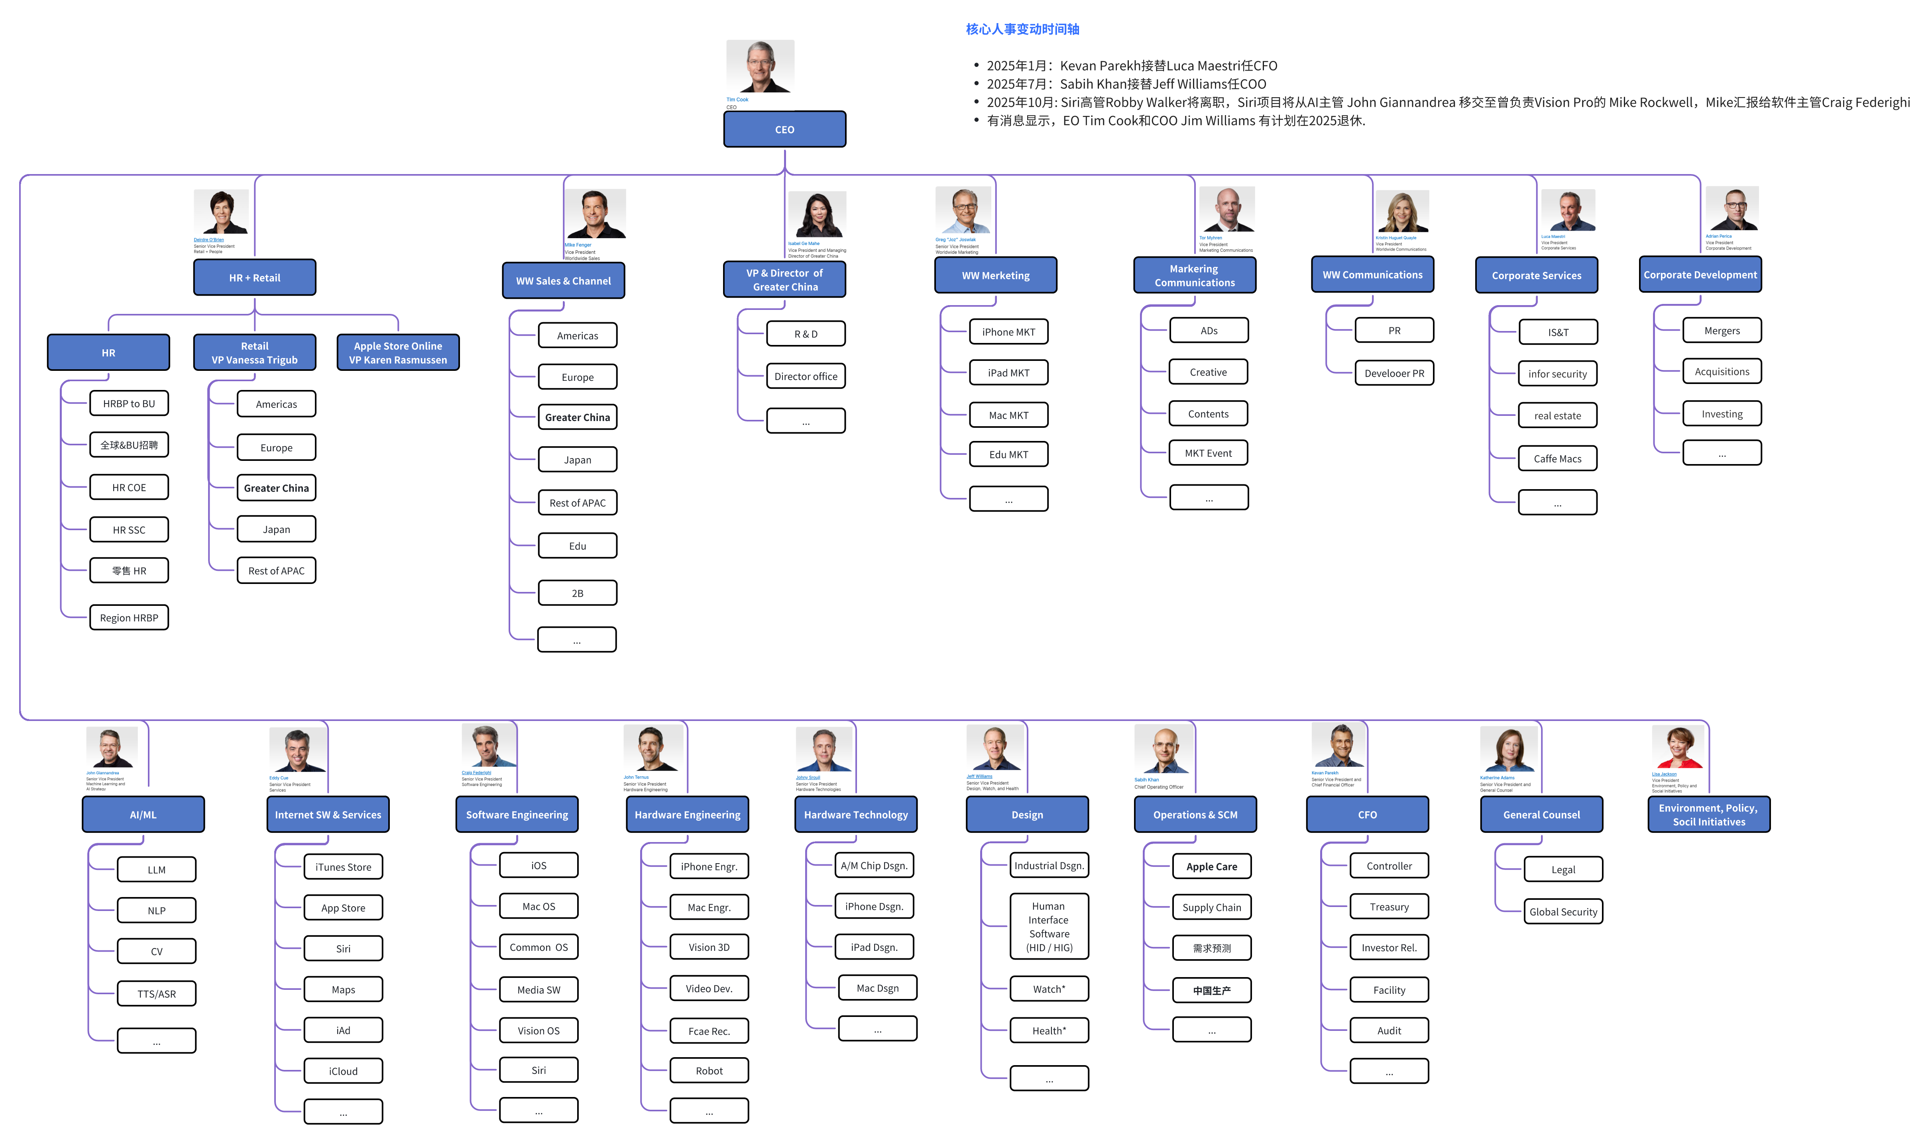

6.9.2 FS GC Org-X

6.9.2.1 Customer Key Executive Coverage Status.

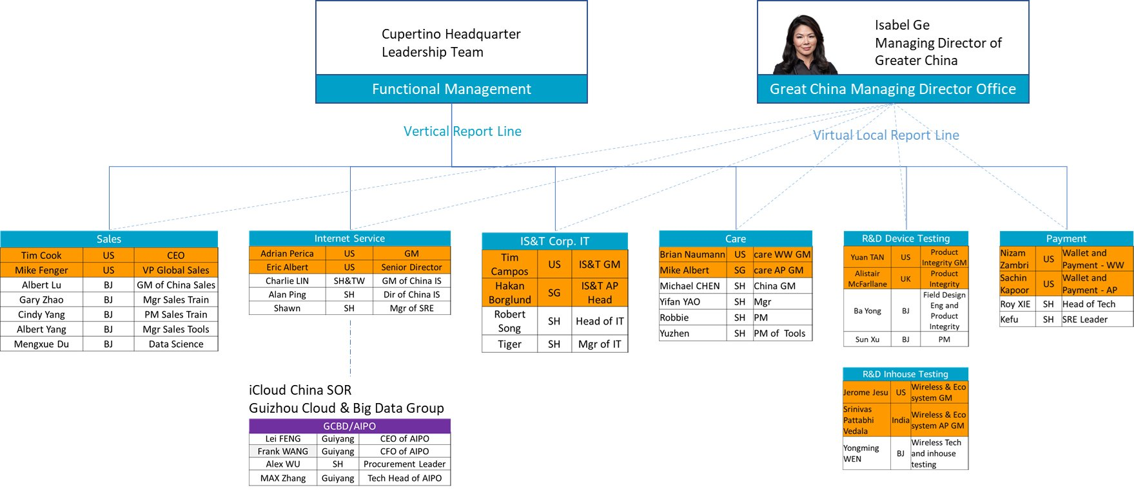

Name | Title | Level of influence | Biz Focus | Relationship | Coverage | Owner of Contact | Comment
Isabel Ge Mahe  葛 越 | VP and Managing Director of Greater China | Influencer/Decision Maker | Provides leadership and coordination across China-based team |  | None |  | VP, FS GC
Brian Lu  卢 雷 | Director of China Sales | Decision Maker | GC's channel revenue growth |  | None |  | Channel Sales
Stella Ye  叶 迈 | General Manager, GC EDU & ENT of Channel Sales | Decision Maker | 1. GC's channel revenue growth.  2. B2B MKT Penetration.  3. Reseller enablement. | Positive | Low |  | Channel Sales
James | Manager of SE, GC EDU & ENT of Channel Sales | Influencer | 1.Sales-driven solutions support and technological innovation | Neutral | Low |  | Channel Sales
Toby Tian | DPM team Manager, GC Channel Sales | Influencer | Leverage data and AI capabilities to enhance channel sales efficiency | Negative | Low |  | Channel Sales
Roger Zhou  周 睿 | CDA team manager, GC Channel Sales | Decision Maker | Leverage data and AI capabilities to enhance channel sales efficiency | Positive | Low |  | Channel Sales
Boyan Liu  刘 柏延 | ML Engineer | Influencer | 1. Deliver high-quality products efficiently  2. Ensure secure, compliance, and stable application operation | Positive | Medium |  | Channel Sales
Mengxue Du  杜 梦雪 | ML Engineer | Influencer | Same as ablove | Positive | High |  | Channel Sales
Robert Song | Director. IS&T | Decision Maker | 1. China local IT spending efficiency  2. IT security and compliance risk control | Negative | Low |  | IS&T  Ali and Tencent is the major local Cloud service provider.
Michael Chen | Director, Care | Influencer | 1. No PR issues for branding, such like 315  2. Operation cost control | Positive | Low |  | Care
Yong Ba | Director, R&D Field Tes | Influencer | 1. Annual new product released on time  2. Operation cost control | Positive | Low |  | R&D Field Tes
Roy Xie | Head of wireless Tech, Payment | Influencer | 1. Ensure secure, compliant, and stable application operation | Neutral | Low |  | Payment(WPC)
Kefu Xu | SRE Leader of wireless Tech, Payment | Influencer | 1. Ensure secure, compliant, and stable application operation | Neutral | Medium |  | Payment(WPC)
Charlie LIN | Director, Internet Service | Influencer | 1. Operation cost control | Neutral | Low |  | AIPO  QBR with CM/CT/CU and BAT
Lei Feng | CEO, AIPO | Decision Maker | 1. Excellent operation as SOR | Neutral | Low |  | AIPO  CM, CT, CU VP annually meet. BAT VP level annually meet.
Xin Wang | CFO/CIO, AIPO | Influencer | 1. Cost control | Neutral | Low |  | AIPO  CM, CT, CU VP annually meet. BAT VP level annually meet.
Level of influence: Decision Maker / Influencer / Executor
Relationship: Positive/Neutral/Negative
Coverage: High/Medium/Low/None

6.9.2.2 Influence Map:
C-Suite/LoB | Customer Profile
 | Decision Maker (Y/N) | Influencer (Y/N) | Manner (Support/Neutral/Negative) | Top 3 Business Indicator
Isabel Ge - Managing Director of GC | N | Y | Neutral | 1/ Provides leadership and coordination across China-based team
Brian Lu - MD of GC Sales | Y | Y | Neutral | 1/ China Revenue and iPhone sales
Stella Ye- GM of GCR channel sales | N | Y | Support | 1/Business innovation  2/Channel sales growth  3/ GenAI use case
Micheal CHEN - Director of GC Care | Y | Y | Support | 1/ No PR issues for branding, such like 3152/ Operation cost control
Ba Yong - Director of GC R&D | N | Y | Support | 1/ Annual new product released on time2/ Operation cost control
Charlie LIN - Director of GC Internet Service | N | Y | Neutral | 1/ Operation cost control
Dennis Grueskin- Senior Director Procurement at Apple | Y | Y | Neutral
Fei Lei - AIPO CEO | Y | Y | Neutral | 1/ Excellent operation as SOR
Frank Wang - AIPO COO/CFO | N | Y | Support | 1/ Cost control

6.9.2.3 FS GC Main Entities
FS GC Entities in CN | FS GC Entities in EN | LoB | City
苹果(中国)有限公司 | Apple (China) Co., Ltd. | investing 12 Chinese entities | 宁波
苹果电子产品商贸（北京）有限公司 | Apple Electronic Product Commerce (Beijing) Co., Ltd. | Retail | 北京/上海/广州/深圳/天津/武汉/长沙
苹果电脑贸易（上海）有限公司 | Apple Computer Trading (Shanghai) Co., Ltd. | Channel Sales | 上海/北京/广州/深圳/成都/...
苹果技术服务(上海)有限公司 | Apple Technical Services (Shanghai) Co., Ltd. | Care | 上海
苹果研发（北京）有限公司 | Apple R&D (Beijing) Co., Ltd. | R&D | 北京/朝阳/海淀 上海/苏州/深圳
苹果电脑系统工程(上海)有限公司 | Apple Computer System Engineering (Shanghai) Co., Ltd. | System Engineering | 上海
苹果采购运营(上海)有限公司 | Apple Procurement Operations (Shanghai) Co., Ltd. | Procurement | 上海
电脑贸易，电子产品商贸的子公司… | Subsidiary of Channel Sales / Retail | Channel Sales/ Retail

6.9.3 FS Central Team Org-X:
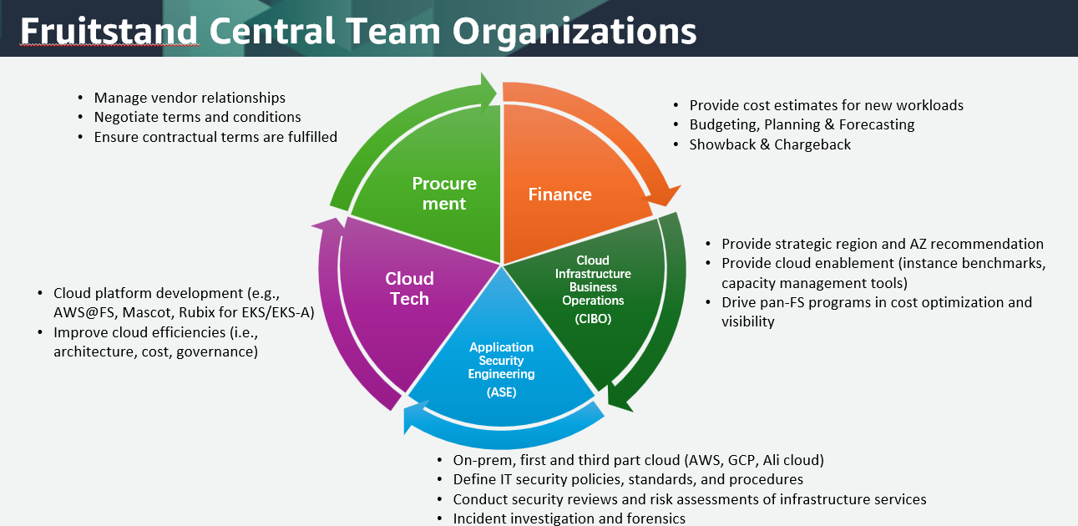

6.9.4 Related reports are as follows:
- 工业和信息化部部长李乐成会见美国苹果公司首席执行官蒂姆·库克, October 20, 2025, from 环球网
- Alibaba and Apple Partner on On-Device AI in China, June 16,2025 from Yahoo
- iOS 18.6 Apple Intelligence Launch in China Delayed by U.S.-China Trade Tensions, June 4,2025
- 库克访华并透露 Apple Intelligence 进展, April 01, 2025
- Apple will integrate Alibaba’s AI into iPhones in China, Chairman Joe Tsai says, Feb 13, 2025 from CNBC

6.9.5 2024 Global and Chinese Smartphone Market Overview:
The smartphone market recovered to 1.24B shipments ($478B revenue) in 2024, showing 7% YoY growth. Industry projections indicate $485B revenue in 2025, with a Compound Annual Growth Rate (CAGR) of 3.8% through 2030.
The premium market has consolidated into two ecosystems: Fruitstand's iOS vs. Android manufacturers. Despite similar shipment volumes with Samsung (18.7% vs 18%), FS captures 42% of industry revenue through its tightly controlled ecosystem, maintaining $1,100-1,200 ASP and 48% gross margin, far exceeding Android competitors like Samsung (11-12% margin).
Company | 2024 Rev $B | 2024  Rev Share | 2024  Shipments  M | 2024  Shipments Share | 2023  Shipments  M | 2023  Shipments Share | 2024/2023  Shipments Growth
Apple | 201 | 42% | 232 | 18.70% | 234.3 | 20.10% | -0.90%
Samsung | 110 | 23% | 223 | 18.00% | 226.7 | 19.50% | -1.40%
Xiaomi | 28 | 8% | 168 | 13.60% | 146 | 12.50% | 15.40%
Transsion* | 14 | 3% | 106 | 8.60% | 94.9 | 8.20% | 12.70%
OPPO* | 24 | 5% | 104 | 8.50% | 103.4 | 8.90% | 1.40%
Others | 101 | 19% | 402 | 32.50% | 358.9 | 30.80% | 12.30%
Total | 478 | 100% | 1,236 | 100.00% | 1164.1 | 100.00% | 6.40%

In 2024, China's smartphone market grew 4% YoY. While FS in Greater China Market remains crucial as the third-largest market ($66B, 17% of global revenue, YoY -8%) and primary supply chain hub (44% of direct procurement).
FS is strategically balancing market opportunities and geopolitical risks. FS is actively engaging with China's MIIT(中国工信部), Alibaba to accelerate the deployment of its AI services in China, enhancing local market adaptation and strengthening its position in this key region.
Company | 2024 Rev $B | 2024  Rev Share | 2024  Shipments  M | 2024  Shipments Share | 2023  Shipments  M | 2023  Shipments Share | 2024/2023  Shipments Growth
Apple | 66 | 36% | 42.9 | 15% | 51.7 | 19% | -17%
Vivo | 32 | 17% | 49.3 | 17% | 44.4 | 16% | 11%
Huawei | 30 | 16% | 46 | 16% | 33.6 | 12% | 37%
OPPO | 22 | 11% | 42.7 | 15% | 44 | 16% | -3%
Honor | 22 | 11% | 42.2 | 15% | 43.5 | 15% | -3%
Xiaomi | 9 | 5% | 28.0 | 10% | 26.5 | 9% | 6%
Others | 8 | 4% | 34 | 12% | 40.3 | 14% | -16%
Total | 189 | 100% | 285 | 100% | 273 | 100% | 4%

This data highlights FS's premium market strength globally and in China. Meanwhile, FS still faces uncertainties from macro-econ, geopolitics, tech revolutions & fierce mkt competition, impacting sales & op costs.

6.9.6 History revenue:

6.9.7 Existing workload instruction:
LoB | workload | ARR K  After ITA | AWS Services | related APNs | Why AWS
Channel Sales | AI Coach LLM+RAG | 200 | H20/A100/T4 | NA | C2C,  1.Operator's AWS usage habits.  2.Cost-effective provision of H2O critical resources.  3.Tight timeline, Ali cannot complete the network configuration in the short term.
 | Digital Human | 150 | MP2P ZITZO | ZITZO/Hudao | C2C, Cost-effective APN solution
RnD | Global unified data transfer testing | 50 | EC2 | DTO | NA | G2C, Global consistency requirements.
Care | APJ Care-ServiceOne | 30 | EC2 | RDS | ServiceOne | C2G, AWS is the preferred choice.
AIPO | iCloud control Engineering | 70 | Route 53 | NA | C2C, Early-stage project initiated in 2018

6.9.9 Additional Attachments

Fruitstand 10-K for Financial Year 2025.pdf
Fruitstand Annual Shareholders Meeting Proxy_Statement_2025.pdf
Strategy session sharing from Fruitstand account Tunc - Oct 2024.pdf
Apple SWOT Analysis
Analyzing Apple’s Financial Strategy & Goals Over the Years

Amazon Confidential

